**Customer Retention Data Analysis Project**



**Problem Statement**

Customer satisfaction has emerged as one of the most important factors that guarantee the success of online store; it has been posited as a key stimulant of purchase, repurchase intentions and customer loyalty. A comprehensive review of the literature, theories and models have been carried out to propose the models for customer activation and customer retention. Five major factors that contributed to the success of an e-commerce store have been identified as: service quality, system quality, information quality, trust and net benefit. The research furthermore investigated the factors that influence the online customers repeat purchase intention. The combination of both utilitarian value and hedonistic values are needed to affect the repeat purchase intention (loyalty) positively. The data is collected from the Indian online shoppers. Results indicate the e-retail success factors, which are very much critical for customer satisfaction.

**Analysis of the following is performed in this Project**:

# Dataset: Taken the given data set

# Approach (Architecture):

[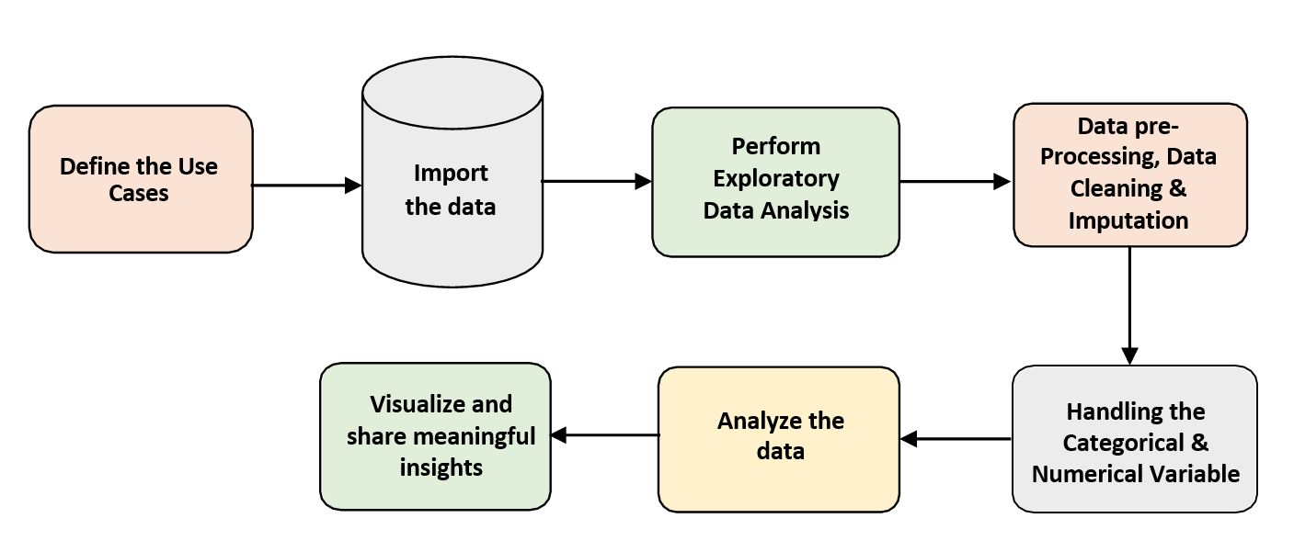](https://user-images.githubusercontent.com/84115928/137479294-ccfa21f9-81e1-4de8-8f96-15ddefdec06e.JPG)

# Tools Used:-

# 

**Brief Analysis: -**

* Customer retention is not only a cost effective and profitable strategy, but in today’s business world it is necessary. This is especially true when you remember that 80% of sales come from Existing customers and 20% of Sales from New customers.
* A company’s ability to attract and retain new customers, is not only related to its product or services, but strongly related to the way it services its existing customers and the reputation it creates within and across the marketplace.

Here we need to analyse the giver Dataset for trending customer requirements. The Dataset contains huge no of columns which effects the customer purchase and re-purchase habits. In order to get accurate outcome we need to consider all columns.

Some of Insights from the Given Dataset:-

1. Female customers are high in no. as compared to Male.
2. The shopping habits are varying according to their age and income people in between 21-40 are young and earning stage so there is high and below 20 are low in no. and above 50 are not showing interest on online purchases.
3. There is high orders from the Tire-1 cities like Delhi, Noida and low orders from Tier-2 cities like Gaziabad, Merut, Solan. Even though Bangalore is Tire-1 city online orders for that also low as compared to Delhi and Noida.
4. From the last 4 years data past 2 years customer online purchase habits are reducing year by year.
5. As compared to using wi-fi for online purchase , purchase through mobile (data) is increased because of it’s ease.
6. Orders from the smart phone increased as compared to   
   Laptop, Desktop, and Tab.
7. Google Chrome is using highly for searching or ordering the product through online.
8. Customer spending habits are changed from, cash on delivery , E-wallets to Credit/Debit card purchases.
9. Customers looking for more offers when they are purchasing.
10. Customers are purchasing when the content of website is easy to understand.
11. Customers are purchasing when the payment method is ease.
12. Customers are considering the websites which giving security to their personal Data.
13. Customers preferring the sites which giving high discount i.e high volume of monetary benefits.
14. Customers preferred to purchase which website return and replacement policy is ease.
15. Customers preferring which website giving better information about the product.

**Conclusion:-**

Finally customers preferring which is giving high monetary benefits.

With given data we can understood that Most of the people preferring Amazon.

Customers think that Amazon.com is most trust – worthy, ease to use, and giving

high monetary value.